# Exercise 1

**f.m:**

function y = f(x)

y = x^2;

end

# Exercise 2

**Plot_f.png**

x = -10:0.1:10;

y = x.^2;

plot(x, y);

title('Plot of f(x) = x^2');

xlabel('x');

ylabel('f(x)');

saveas(gcf, 'plot_f.png');

# Exercise 3

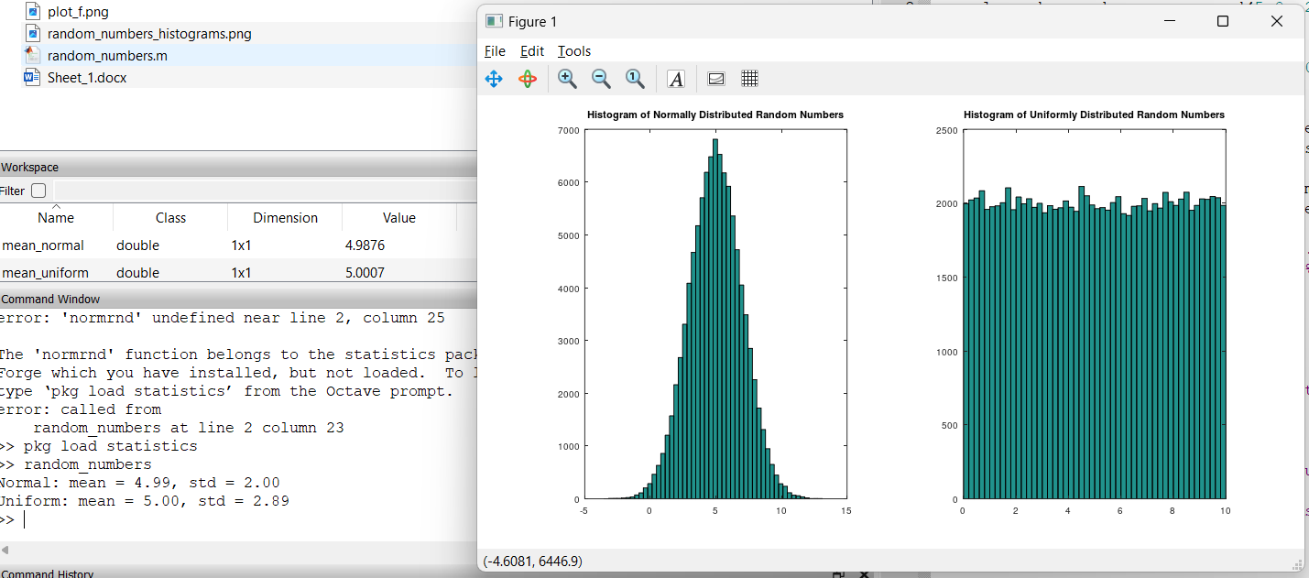

**random_numbers.m**

% Part a

normal_random_numbers = normrnd(5.0, 2.0, [1, 100000]);

% Part b

uniform_random_numbers = rand(1, 100000) * 10;

% Part c

mean_normal = mean(normal_random_numbers);

std_normal = std(normal_random_numbers);

mean_uniform = mean(uniform_random_numbers);

std_uniform = std(uniform_random_numbers);

fprintf('Normal: mean = %.2f, std = %.2f\n', mean_normal, std_normal);

fprintf('Uniform: mean = %.2f, std = %.2f\n', mean_uniform, std_uniform);

% Part d

figure;

subplot(1, 2, 1);

hist(normal_random_numbers, 50);

title('Histogram of Normally Distributed Random Numbers');

subplot(1, 2, 2);

hist(uniform_random_numbers, 50);

title('Histogram of Uniformly Distributed Random Numbers');

saveas(gcf, 'random_numbers_histograms.png');